Benchmarking TC-06
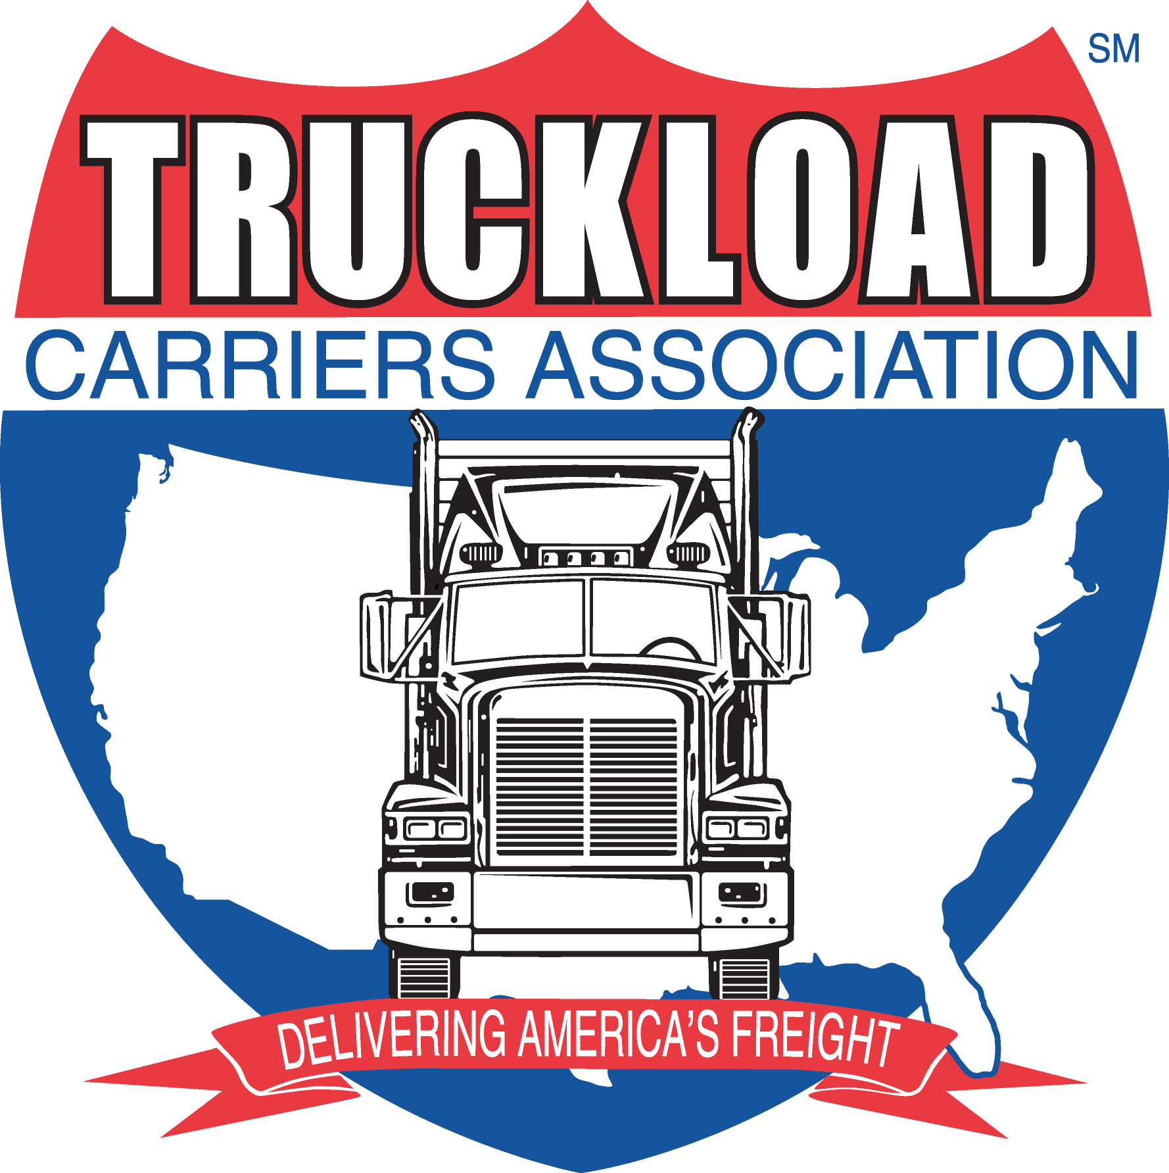

CHAIRMAN: Karen Smerchek-JVT

VICE CHAIRMAN Jeff Reed-Skyline

FINANCIAL ADVOCATE: Dave Slesinski – MCS

TCA STAFF LIAISONS: Debbie Sparks

DECISIV MODERATOR: Jack Porter

MEETING Recap
DATE AND TIME: Tuesday April 2nd: 12PM – 5PM
Wednesday April 3rd: 7AM – 12PM

PLACE: Renaissance Chicago O'Hare Suites Hotel
Chicago, IL

Tuesday April 2nd

- Call to Order at 1PM
  - Opening Comments from Chairman & Moderator
  - All Members present except Fleetmaster, No Carrier Guests
  - Review Agenda
  - Anti-Trust Review

- “Hot Topics”- After concluding your 2013 Business Forecast, we will go around the room and get each Members outlook for 2013.
  - Group Consensus 0-20% Growth in 2013
  - New Equipment, better fuel and depreciation
  - Lower Maintenance Costs
  - Some Rate Increases but negligible
  - Better Lane density, and core networks
  - Operational Efficiencies through scorecards and technology

- Special Meeting Composite Review: See the TCA Website for the Meeting Presentation PowerPoint

- Headcount Survey and Discussion: See the TCA Website for the Survey Results

- Organizational Chart Review: See the TCA Website for the Meeting Presentation PowerPoint

- ADMINISTRATION:
  - Old Business – the group likes the current meeting formats
    - Start at Noon with Lunch in the Room to a 1pm Start
    - Group Dinner – prefer private room at Gibson’s
    - Day 2 starts at 6:30am with breakfast in the room, and 7am Start
    - Ending at Noon
  - New Business
    - Wreaths Across America Gala will be in DC 9/12
    - Developed an Agenda Committee
      - Jon Vinje
      - Mike Maiore
      - Jim Ward
    - Developed a Membership Committee
      - Keith Tuttle (Immediate Past Chairman)
      - Karen Smerchek (Current Chairman)
      - Jeff Reed (Current Vice Chairman)
    - Will ask Decisiv to develop a quarterly review portion of the composite for the next Special meeting.
  - Membership
    - Hummer has decided to leave the group
    - Fleetmaster needs to be contacted for the future participation
    - TCA has some members requesting entry, and will vet them with the new Membership Committee
  - Meetings:
    - November 4th & 5th – Chicago: Ops/Drivers Quiz before meeting

Wednesday, April 3rd

- Best Idea Session (@7am): Bring your Best Idea that you have used in the past year! See the TCA Website for all the Best Ideas.

Halvor Lines – Health & Wellness Initiative

Bowman – Shift Analysis

Veriha – Spot Pricing Tool

Performance Pay: See the TCA Website for the Meeting Presentation PowerPoint

Scorecards in the Business:

Most people using Driver Scorecards for Performance Evaluation & Tracking

Some people have internal Customer Scorecards

Most Fleets get Service Scorecards from their Shippers

Very few have Driver Manager Scorecards, and they should be an aggregation of the Driver Scorecards.

- Employment Reviews: See the TCA Website for the Meeting Presentation PowerPoint

- Adjourn:

