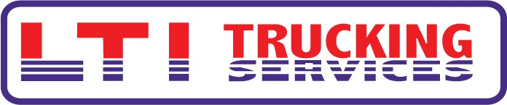

BEST PRACTICE IDEA

NEED:
REDUCE INJURIES AND ACCIDENTS

SOLUTION:
SAFETY AWARENESS PROGRAM:
INTRODUCE NEW SAFETY MANUALS
ASK DRIVERS TO SIGN SAFETY AGREEMENT
PRESENT SAFETY INCENTIVE

IMPLEMENTATION:
PRESENT SAFETY AWARENESS PROGRAM AT FALL SAFETY MEETINGS

RESULTS:
ACCEPTANCE OF THE PROGRAM HAS BEEN VERY POSITIVE. EVERYONE HAS WILLINGLY SIGNED SAFETY AGREEMENT

NEED: WORK COMP EXPENDITURES WERE EXCEEDINGLY HIGH AND WILL HAVE AN EFFECT ON OUR RENEWAL PREMIUM. THERE WAS A NEED TO REDUCE INJURIES AND ACCIDENTS IN ORDER TO MITIGATE WHAT WE WILL HAVE TO PAY IN THE FUTURE.
SOLUTION: I ATTENDED THE TCA SAFETY SEMINAR IN LOUISVILLE, KY THIS PAST SPRING AND CAME AWAY WITH A LOT OF INSIGHT INTO WHAT OTHER COMPANIES WERE DOING WITH THEIR SAFETY PROGRAMS. I ALSO ATTENDED SEMINARS PUT ON BY LIBERTY MUTUAL. I WAS LOOKING FOR SOMETHING THAT CAME BETWEEN REWARD FOR GOOD BEHAVIOR AND PUNISHMENT FOR BAD BEHAVIOR. AFTER REVIEWING MANY DIFFERENT OPTIONS, I DECIDED TO STEER AWAY FROM GROUP REWARD OR GROUP PUNISHMENT. I FELT THAT IT PUT TOO MUCH PRESSURE ON AN INDIVIDUAL NOT TO REPORT A LEGITIMATE INJURY. WITH THE HELP OF LIBERTY MUTUAL, I PUT TOGETHER A SAFETY MANUAL USING OUR OWN DRIVERS PICTURES PERFORMING PROPER SAFETY PROCEDURES. I ALSO CREATED A SAFETY PROCEDURE AGREEMENT THAT THE DRIVERS WOULD SIGN. WITH THE COOPERATION OF MANAGEMENT, I CREATED AN INCENTIVE PROGRAM THAT WOULD REWARD THOSE DRIVERS WHO QUALIFIED.
IMPLEMENTATION: THE SAFETY AWARENESS PROGRAM WAS ROLLED OUT AT OUR FALL SAFETY MEETINGS. QUALIFIER NUMBER ONE IS ATTENDANCE AT OUR SAFETY MEETING. SAFETY MEETINGS ARE CONDUCTED OVER SIX CONSECUTIVE SATURDAYS.
RESULTS: ACCEPTANCE OF THE PROGRAM HAS BEEN VERY POSITIVE. DRIVERS ARE WILLINGLY SIGNING THE SAFETY PROCEDURE AGREEMENT.

